|  |
| --- |
| Close-up image showing the leaf-sides of two oversized books side-by-side on a bookshelf, with additional books in soft focus background |
| **SMART-PHONE- Bluetooth Interface Controlled Light System** |
| |  |  |  | | --- | --- | --- | | Swarup Deb | 11/3/19 | 19BCG1077 | |

**EXP4_SMART-PHONE-** **Bluetooth Interface Controlled Light System**

**CIRCUIT DIAGRAM:**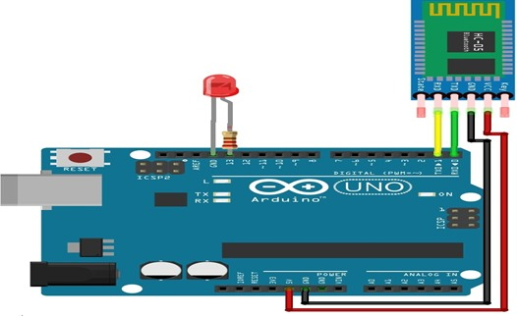

**THEORY:**

Assemble the circuit as shown in the circuit diagram. Open Arduino IDE and compile the program (sketch). Upload the sketch

to Arduino board. Switch on the power supply to Arduino by connecting it to 5V power source.

Pair Bluetooth module with your Android phone. Type password ‘1234’ (default password) of Bluetooth module.

Click Bluetooth Image on the app to connect it with the Bluetooth module. It automatically connects and displays as Connected in the app.

You are now ready to control the appliances using the app. You can either use on/off buttons to control the appliances.

You can control more electrical appliances by increasing the number of channels in the relay. For instance, using an 8-channel relay,

you can control up to eight devices.

For this, you need to alter the source code by adding input commands and voice commands to control the devices.

**LEARNING AND OBSERVATIONS:**

As per the Arduino code,The app on your smartphone sends data when you click on buttons via Bluetooth in the

mobile to Bluetooth module HC-05 connected with Arduino board. Received data pin TX of the HC-05 is connected to Arduino RX pin.

Arduino Uno processes the received data and controls the relay board accordingly.

**PROBLEMS AND TROUBLESHOOTING:**

You should take care whether the board in the arduino\uno or not and also selection of port in tools and check whether the conected

bluetooth is yours or not.This is the biggest problem in this experiment.

**PRECAUTIONS:**

While installing led’s in bread board we should take care whether the ’n’ terminals is connected to ground or not.Here the ‘n’ terminals

should be connected similarly, we should check whether the ‘p’ terminals are connected to pin 13 or not.

Check whether RX Pin of aurdino and TX pin of Bluetooth is used or not.

Install the wires properly in both bread board and arduino board.